PANDIT DEENDAYAL ENERGY UNIVERSITY
SCHOOL OF TECHNOLOGY


Course: Database Management System Lab
Course Code: 20CP208P
Project Report
BTech in Computer Science and Engineering
Semester:3

Submitted To: Submitted By:
Dr. Debabrata Swain 24BCP067, 24BCP046, 24BCP041

Certificate

This is to certify that the Practical lab report of the course entitled “Database Management System Lab” has been satisfactorily completed and submitted by Krissa Jiyani (24BCP067), Vruti Vaghasia(24BCP046) & Diya Patel(24BCP041) of 3th Semester, CSE Department towards the fulfilment of the requirements for the award of the Bachelor of Technology in CSE of School of Technology, Pandit Deendayal Energy University, Gandhinagar is the record of work carried out by him/her under our supervision and guidance. In our opinion, the submitted work has reached the level required for being accepted for the examination. The result embodied in this Project, to the best of our knowledge, has not been submitted to any other university or institution for the award of any degree.

Date: 06/11/2025 Dr. Debabrata Swain
Gandhinagar
Index

Sr. No | Name | Page No. | Sign
1. | Abstract | 4
2. | Introduction | 5
3. | Requirements Analysis | 7
4. | ER Diagram | 12
5. | Relational Schema | 13
6. | SQL Scripts | 21
7. | Query Examples | 24
8. | Testing and Evaluation | 30
9. | Conclusion | 39
10. | Future Enhancements | 39

Abstract

E-commerce is the process of buying and selling goods or services over the internet, as well as the electronic transfer of money and data to complete those transactions. Built by using MySQL, the design supports scalable transaction processing, inventory tracking, and customer interactions, making it suitable for handling high-volume catalogues and user bases. The system is equipped to handle about 10,000 e-commerce records, showcasing its scalability.
Key features of the system include user management where customers can register, sign in and manage their account, Product catalogue and variants where products are organised into categories and support variant attributes, Shopping cart, checkout, order, payment and shipping workflow.
Based on the requirement of the users, the user can extract the transaction idea and get the update about the order. User may filter choices for products based on price or category. Admin may keep a track on the user sessions and receive the session start and end time. Vendors may keep a track of the payment status. The vendor also handles fulfilment: once orders are paid, they dispatch items, update shipping/tracking info, and manage returns or refunds as needed. User queries for refunds and reviews can be handled with ease. In summary, team owners treat the platform as their own online store: from listing products to managing sales, logistics, and growth.
Because of its digital nature, e-commerce greatly expands reach (globally), reduces many of the constraints and offers businesses more flexibility in how they engage with customers, and analyse data.

Introduction

E-commerce spans a broad spectrum of online business models — from consumer retail to business-to-business procurement, digital services, mobile commerce and many more. It includes expanded reach, lower operational costs compared to physical stores, scalability, data-driven personalization and the ability to operate 24/7. When designed well, it provides a seamless experience for users and an efficient, scalable operational framework for the business.

Real-Life Problem Solved by the Project
Problem Statement
E-commerce systems are often:
- Manual or semi-digital.
- Prone to human error, especially in inventory management, order processing and financial tracking.
- Lacking real-time updates, integrated data flows or analytics for performance insight and personalised experience.

Solutions offered by the project
The E-commerce System solves these issues by:
- An online platform built using modern web technologies (e.g. MySQL) thereby enabling customers to browse, search, select and purchase products 24/7 from any device.
- Advanced product management.
- Shopping cart and checkout workflow, integrating payment processing, order capture, updates and confirmations, thereby reducing manual effort and error-prone processes.
- Real-time order fulfilment and logistics tracking, where order status, shipping, delivery and returns are monitored through the system, improving transparency and customer trust.
The system is scalable and adaptable, making it deployable in real-world use.

Requirements Analysis
E-Commerce Shopping System: -
Our E-Commerce System database is designed to manage the wide network that make online retail seamless. From customers, sellers, and products to orders, payments, delivery, and customer support, it integrates every part of the digital marketplace. The system highlights data performance, and scalability, ensuring a smooth experience for both shoppers and administrators while keeping information valid and easily accessible.

Functional Requirements
1. Customer Management
- It stores and manages customers detail such as name, email, and address.
- Each customer will have a unique identifier (id) to maintain clear records.
- It helps in tracking account creation date, preferences, and loyalty status for distinctive service.
2. Product and Category Management
- Stores product details such as name, price, description, stock quantity, and images.
- Organizes products into categories and subcategories.
- Implement product variants for size, colour, and other attributes.
3. Warehouse Management
- Tracks stock level across multiple warehouses and manage delivery schedules and supplier relationships.
- Support automated alerts for low-stock products to streamline restocking.
4. Order and Payment Management
- Handle order creation, status tracking (delivered or pending).
- Support multiple payment methods — credit/debit cards, net banking, UPI, COD, and Wallets.
- Maintain transaction records with payment verification and link payments to corresponding orders.
5. Shopping Cart and Wishlist
- Allow customers to add, update, or remove products in their cart.
- Enable saving products to a Wishlist for future purchases.
6. Delivery and Logistics
- Manage delivery partners, shipment tracking numbers, and estimated delivery dates.
- Enable order status updates in real time and handle returns and refunds.
7. Offers and Discounts
- Manage promotional offers, discount codes, and their validity periods.
- Associate offers with specific products, categories, or customers.

Non-Functional Requirements
Performance: It must efficiently handle thousands of concurrent users and queries.
Scalability: It supports growth in users, products, and orders without major architectural changes and can handle distributed databases.
Data Integrity: Applies referential integrity using primary and foreign keys and uses constraints like CHECK, UNIQUE, and NOT NULL to prevent invalid entries.
Security: Encodes sensitive data such as passwords, payment info, and personal details.
Maintenance: It includes regular automated backups and recovery plans. It keeps database modular for easy schema updates and maintenance.
Usability: Provide instinctive SQL queries and stored procedures for reports such as sales trends, top products, customer activity.
System Requirements
Hardware Requirements
- Intel i3 Processor or above
- 500KB storage for project setup
Software Requirements
- MySQL Server
Technologies Used
- Database: MySQL
- AI Chatbot: OpenAI GPT

Normalisation
  - 1 NF
A table is in 1NF if:
- Each cell contains atomic (indivisible) values containging a single value and no multi values.
- Each record is unique (no duplicate rows).
Applied in project:
- All tables (e.g., users, product, orders, etc.) have primary keys.
- Each column holds only one value (no repeating groups or arrays).

  - 2 NF
A table is in 2NF if:
- It is already in 1NF.
- Every non-key column is fully functionally dependent on the entire primary key, not on part of it.
Applied in project:
- No table has a composite primary key, so partial dependency is impossible.
- For instance, in orders, total_amount, status, and order_date depend entirely on order_id.

  - 3 NF
A table is in 3NF if:
- It is in 2NF.
- It has no transitive dependency.

Applied in project:
- Example: In user_address, attributes like city, state, pincode depend directly on add_id (primary key), not on user_id.

  - BCNF
A stricter version of 3NF — every determinant must be a candidate key.
Applied in project:
- Each table’s dependencies are based on its primary key.
- Example:
  - In product_discounts, the dependency product_id → discount_percent, start_date, end_date is valid because each discount_id (primary key) uniquely identifies these.

ER Diagram
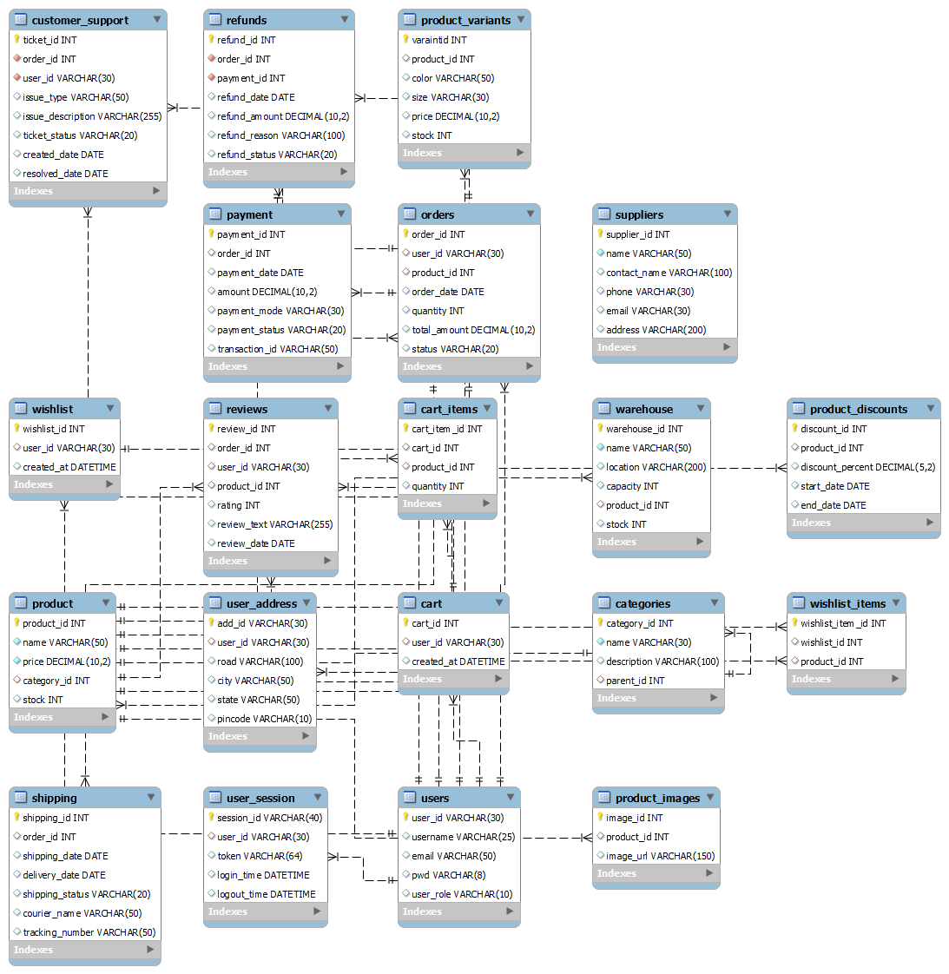

Relational Schema
Definition of tables, columns, data types, and constraints

  - users:
COLUMN NAME | DATA TYPE | CONSTRAINTS
user_id | VARCHAR(30) | PRIMARY KEY
username | VARCHAR(25)
email | VARCHAR(50)
pwd | VARCHAR(8)
user_role | VARCHAR(10)

  - user_address:
COLUMN NAME | DATA TYPE | CONSTRAINTS
add_id | VARCHAR(30) | PRIMARY KEY
user_id | VARCHAR(30) | FOREIGN KEY (user_id) REFERENCES users(user_id);
road | VARCHAR(100)
city | VARCHAR(50)
state | VARCHAR(50)
pincode | VARCHAR(10)

  - user_session:
Column Name | Data Type | Constraints
session_id | VARCHAR(40) | PRIMARY KEY
user_id | VARCHAR(30) | FOREIGN KEY (user_id) REFERENCES users(user_id);
token | VARCHAR(64)
login_time | DATETIME
logout_time | DATETIME

  - categories:
COLUMN NAME | DATA TYPE | CONSTRAINTS
category_id | INT | PRIMARY KEY
name | VARCHAR(30) | FOREIGN KEY (parent_id) REFERENCES categories(category_id);
description | VARCHAR(100)
parent_id | INT | DEFAULT NULL

  - product:
COLUMN NAME | DATA TYPE | CONSTRAINTS
product_id | INT | PRIMARY KEY
name | VARCHAR(50) | NOT NULL
price | DECIMAL(10,2) | NOT NULL
category_id | INT | FOREIGN KEY (category_id) REFERENCES categories(category_id);
stock | INT | DEFAULT 0

  - product_variants:
COLUMN NAME | DATA TYPE | CONSTRAINTS
variant_id | INT | PRIMARY KEY
product_id | INT | FOREIGN KEY (product_id) REFERENCES product(product_id);
color | VARCHAR(50)
size | VARCHAR(30)
price | DECIMAL(10,2)
stock | INT | DEFAULT 0

  - product_discounts:
COLUMN NAME | DATA TYPE | CONSTRAINTS
discount_id | INT | PRIMARY KEY
product_id | INT | FOREIGN KEY (product_id) REFERENCES product(product_id);
discount_percent | DECIMAL(5,2)
start_date | DATE
end_date | DATE

  - suppliers:
COLUMN NAME | DATA TYPE | CONSTRAINTS
supplier_id | INT | PRIMARY KEY
name | VARCHAR(50) | NOT NULL
contact_name | VARCHAR(100)
phone | VARCHAR(30)
email | VARCHAR(30)
address | VARCHAR(200)

  - product_images:
COLUMN NAME | DATA TYPE | CONSTRAINTS
image_id | INT | PRIMARY KEY
product_id | INT | FOREIGN KEY (product_id) REFERENCES product(product_id);
Image_url | VARCHAR(150)

  - warehouse:
COLUMN NAME | DATA TYPE | CONSTRAINTS
warehouse_id | INT | PRIMARY KEY
name | VARCHAR(50) | NOT NULL
location | VARCHAR(200)
capacity | INT
product_id | INT | FOREIGN KEY (product_id) REFERENCES product(product_id);
stock | INT

  - cart:
COLUMN NAME | DATA TYPE | CONSTRAINTS
cart_id | INT | AUTO_INCREMENT, PRIMARY KEY
user_id | VARCHAR(30) | FOREIGN KEY (user_id) REFERENCES users(user_id);
created_at | DATETIME | DEFAULT CURRENT_TIMESTAMP

  - cart_items:
COLUMN NAME | DATA TYPE | CONSTRAINTS
cart_item_id | INT | PRIMARY KEY, AUTO_INCREMENT
cart_id | INT | FOREIGN KEY (cart_id) REFERENCES cart(cart_id);, ON DELETE CASCADE
product_id | INT | FOREIGN KEY (product_id) REFERENCES product(product_id);
quantity | INT | DEFAULT 1, CHECK(quantity > 0)

  - wishlist:
COLUMN NAME | DATA TYPE | CONSTRAINTS
wishlist _id | INT | PRIMARY KEY, AUTO_INCREMENT
user_id | VARCHAR(30) | FOREIGN KEY (user_id) REFERENCES cart(user_id);
created_at | DATETIME | DEFAULT CURRENT_TIMESTAMP
quantity | INT | DEFAULT 1, CHECK(quantity > 0)

  - wishlist_items:
COLUMN NAME | DATA TYPE | CONSTRAINTS
wishlist_item_id | INT | PRIMARY KEY, AUTO_INCREMENT
wishlist _id | INT | FOREIGN KEY (wishlist_id) REFERENCES wishlist(wishlist_id);
product_id | INT | FOREIGN KEY (product_id) REFERENCES product(product_id);

  - orders:
COLUMN NAME | DATA TYPE | CONSTRAINTS
order_id | INT | PRIMARY KEY
user_id | VARCHAR(30) | FOREIGN KEY (user_id) REFERENCES user(user_id);
product_id | INT | FOREIGN KEY (product_id) REFERENCES product(product_id);
order_date | DATE
quantity | INT
total_amount | DECIMAL(10,2)
status | VARCHAR(20)

  - payment:
COLUMN NAME | DATA TYPE | CONSTRAINTS
payment_id | INT | PRIMARY KEY
order_id | INT | FOREIGN KEY (order_id) REFERENCES orders(order_id);
payment_date | DATE
amount | DECIMAL(10,2)
payment_mode | VARCHAR(30)
payment_status | VARCHAR(20)
transaction_id | VARCHAR(50)

  - shipping:
COLUMN NAME | DATA TYPE | CONSTRAINTS
shipping_id | INT | PRIMARY KEY
order_id | INT | FOREIGN KEY (order_id) REFERENCES orders(order_id);
shipping_date | DATE
delivery_date | DATE
shipping_status | VARCHAR(20)
courier_name | VARCHAR(50)
tracking_number | VARCHAR(50)

  - reviews:
COLUMN NAME | DATA TYPE | CONSTRAINTS
review_id | INT | PRIMARY KEY
order_id | INT | FOREIGN KEY (order_id) REFERENCES orders(order_id);
user_id | VARCHAR(30) | FOREIGN KEY (user_id) REFERENCES users(user_id);
product_id | INT | FOREIGN KEY (product_id) REFERENCES product(product_id);
rating | INT | CHECK(rating BETWEEN 1 AND 5)
review_text | VARCHAR(255)
review_date | DATE

  - refunds:
COLUMN NAME | DATA TYPE | CONSTRAINTS
refund_id | INT | PRIMARY KEY
order_id | INT | NOT NULL, FOREIGN KEY (order_id) REFERENCES orders(order_id);, ON UPDATE CASCADE, ON DELETE CASCADE
payment_id | INT | NOT NULL, ON UPDATE CASCADE, ON DELETE CASCADE
refund_date | DATE
refund_amount | DECIMAL(10,2)
refund_reason | VARCHAR(100)
refund_status | VARCHAR(20)

  - Customer_support:
COLUMN NAME | DATA TYPE | CONSTRAINTS
ticket_id | INT | PRIMARY KEY
order_id | INT | NOT NULL, FOREIGN KEY (order_id) REFERENCES orders(order_id);, ON UPDATE CASCADE
user_id | VARCHAR(30) | NOT NULL, FOREIGN KEY (user_id) REFERENCES users(user_id);
issue_type | VARCHAR(50)
issue_description | VARCHAR(255)
ticket_status | VARCHAR(20)
created_date | DATE
resolved_date | DATE

SQL Scripts

Some create queries:

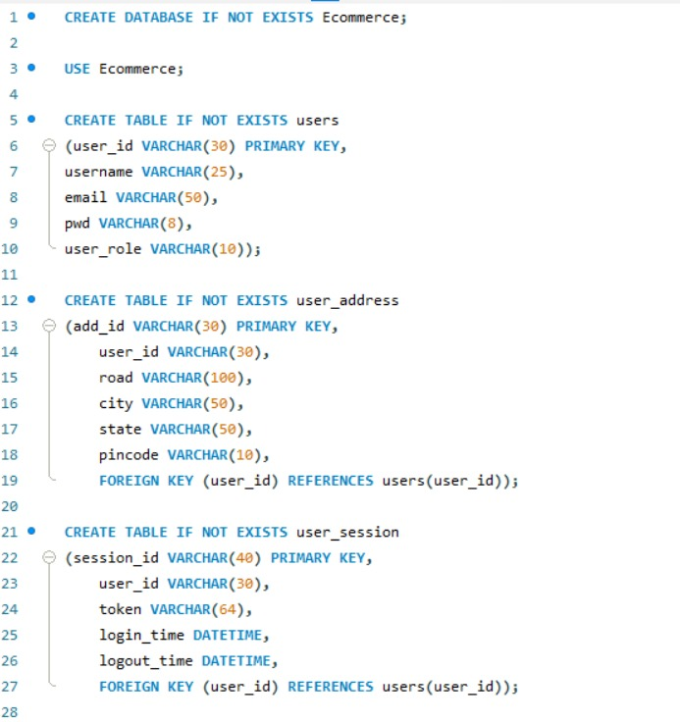
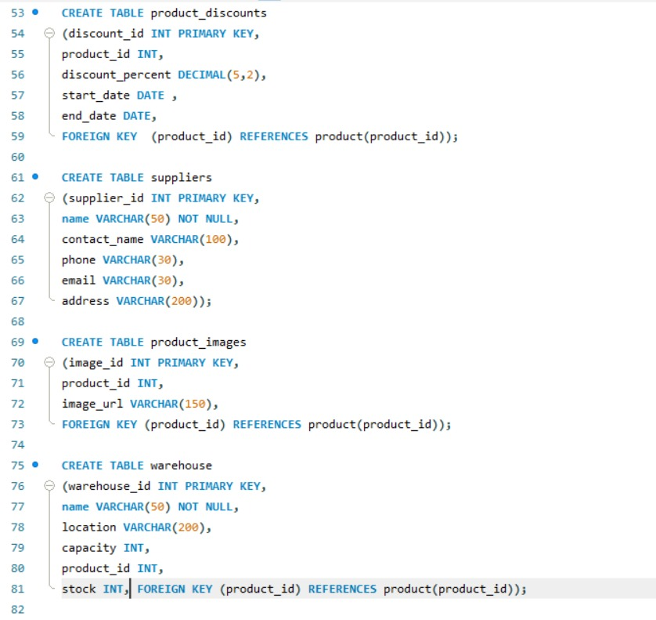

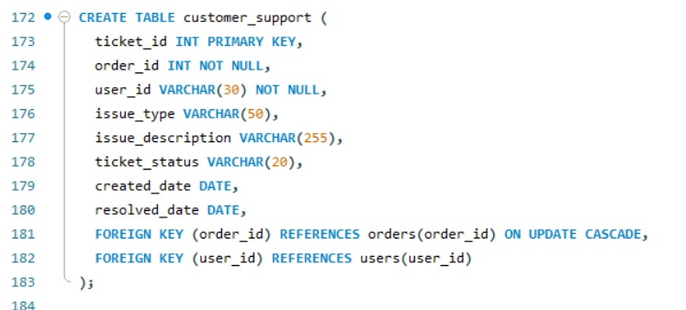
Some insert queries:

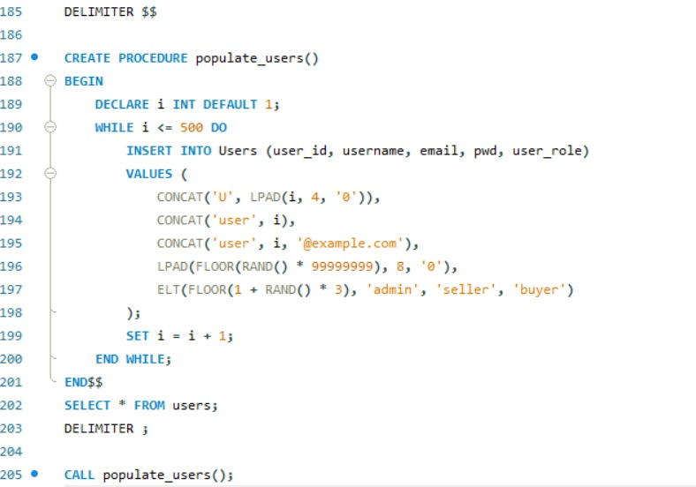

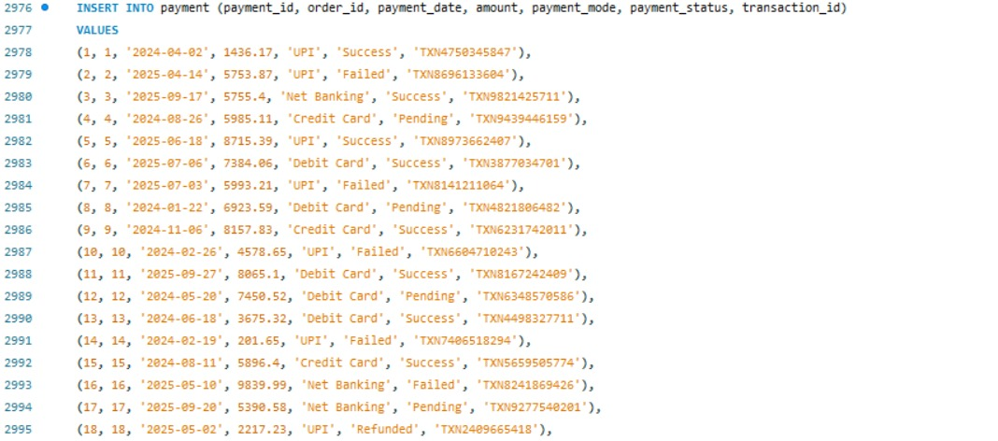

Tables and insertion

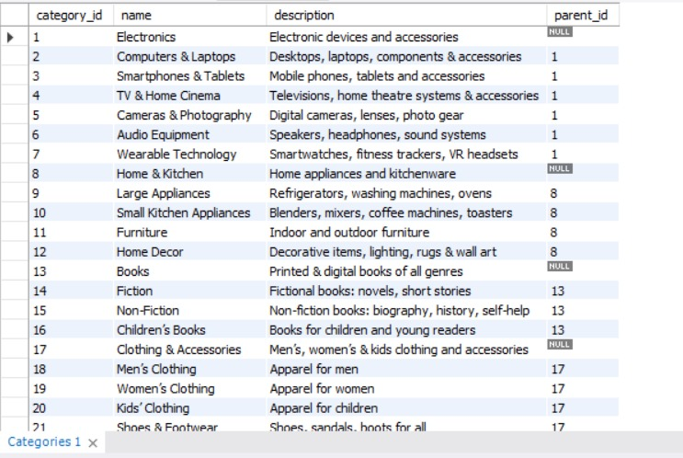
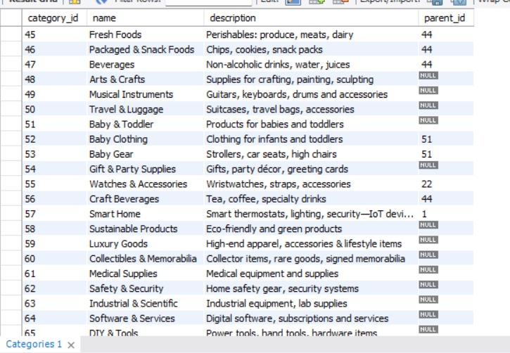
Testing and evaluation

  - Display product id, product name, its category, price and available stock
SELECT
p.product_id,
p.name AS product_name,
c.name AS category_name,
p.price,
p.stock
FROM product p
JOIN categories c ON p.category_id = c.category_id;

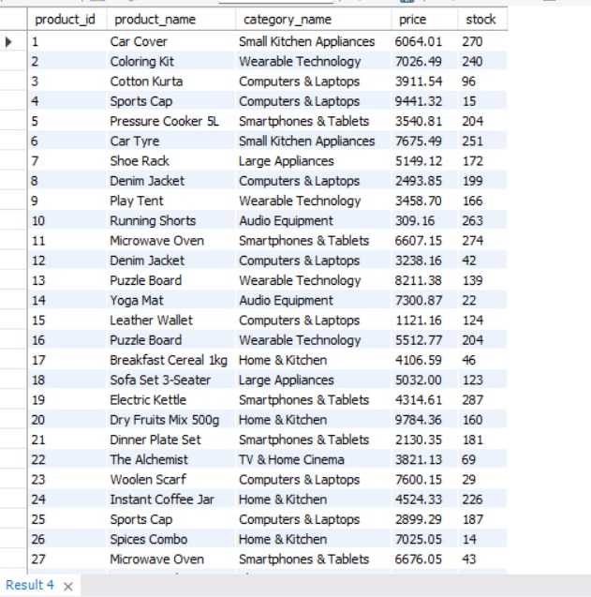

  - Display no of items in the cart per user
SELECT user_id, COUNT(*) AS items_in_cart
FROM cart_items JOIN cart
GROUP BY user_id;
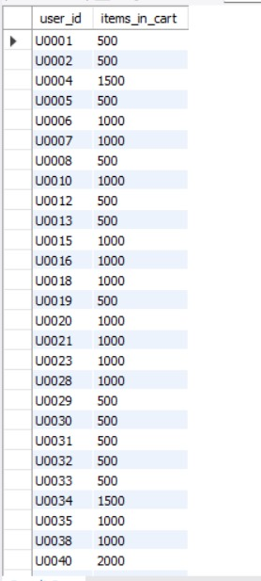

3. Display order details which are shipped.
SELECT
o.order_id,
o.order_date,
o.status,
o.total_amount
FROM orders o
JOIN users u ON o.user_id = u.user_id
WHERE status = 'Shipped';
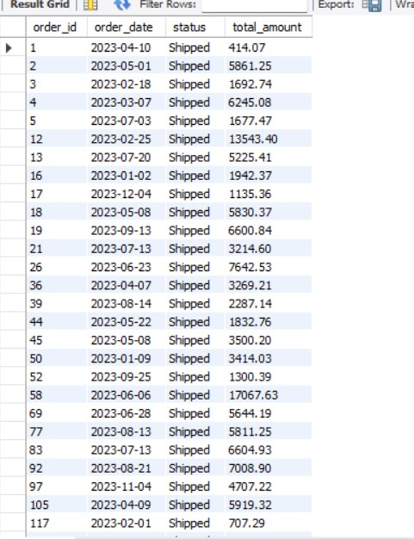

  - Display user address which are in Maharashtra
SELECT user_id, city, state, pincode
FROM user_address
WHERE state = 'Maharashtra';
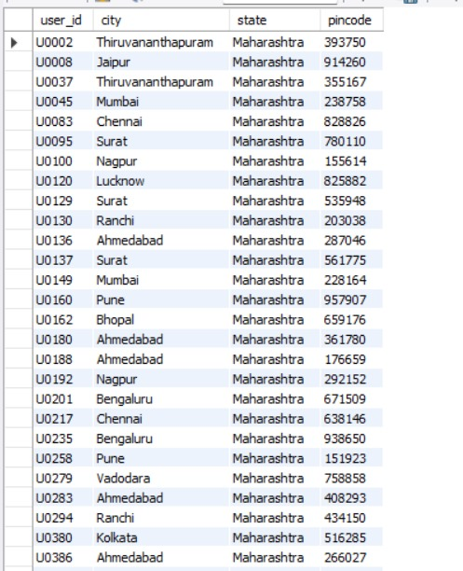

  - Display the order id and user id for which shipping is delayed.
SELECT o.order_id, o.user_id, s.shipping_status
FROM orders o
JOIN shipping s ON o.order_id = s.order_id
WHERE s.shipping_status = 'Delayed';
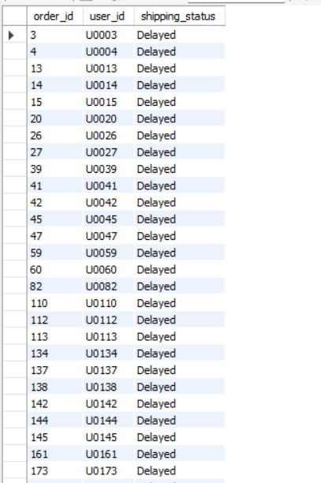

  - Display categories with highest total sales.
SELECT
c.name AS category_name,
SUM(o.total_amount) AS total_sales
FROM orders o
JOIN product p ON o.product_id = p.product_id
JOIN categories c ON p.category_id = c.category_id
GROUP BY c.name
ORDER BY total_sales DESC;
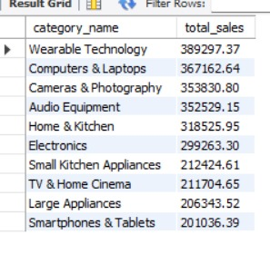
7. Display top 5 products which have maximum reviews.
SELECT
p.name AS product_name,
COUNT(r.review_id) AS total_reviews
FROM reviews r
JOIN product p ON r.product_id = p.product_id
GROUP BY p.name
ORDER BY total_reviews DESC
LIMIT 5;
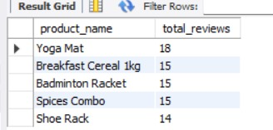

8. Display
SELECT
u.username,
COUNT(o.order_id) AS total_orders,
SUM(o.quantity) AS total_items,
SUM(o.total_amount) AS total_spent
FROM orders o
JOIN users u ON o.user_id = u.user_id
GROUP BY u.username
ORDER BY total_spent DESC;
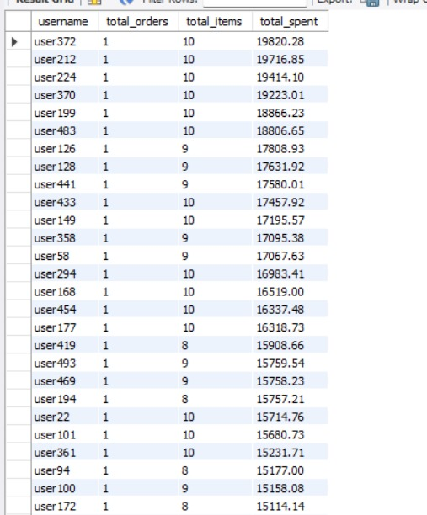

9. Display products from the category = ‘Small Kitchen Appliances’ whose price is less than 1000.
SELECT p.product_id, p.name, c.name, p.price
FROM product p JOIN categories c ON p.category_id = c.category_id
WHERE p.price<1000 AND c.name = 'Small Kitchen Appliances'
ORDER BY p.price;
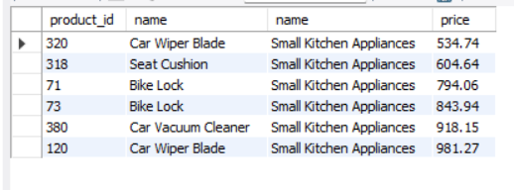
10. Display payment details where payment mode is UPI and payment is successful.
SELECT user_id, payment_date, amount, payment_mode
FROM payment p
JOIN orders o ON p.order_id = o.order_id
WHERE payment_mode='UPI' AND payment_status='Success';
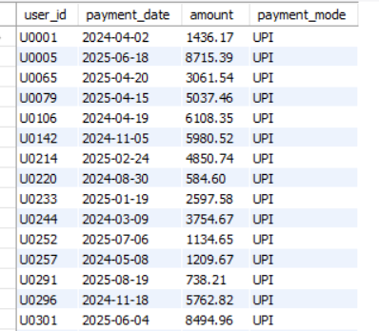

Conclusion

The E-Commerce Database Management System provides a scalable, efficient, and real-world-ready backend solution for managing online retail operations. The system is designed to organize and handle data related to users, products, categories, orders, payments, warehouses, and discounts seamlessly. Built using SQL for the backend, it ensures high data integrity, reliability, and optimized performance for managing large datasets and transactional workflows.
Major features of the system include:
- Comprehensive Product Management: Efficiently handles detailed product information, pricing, stock, and category using relational tables.
- User & Order Tracking: Maintains records of user details, order histories, payment information, and order statuses for complete traceability.
- Inventory & Warehouse Control: Tracks product availability, stock levels, and warehouse distribution to prevent shortages and overstocking.
- Discount & Offers Module: Manages product discounts, validity periods, and seasonal promotions dynamically.
- Secure Database Design: Incorporates primary–foreign key constraints and normalization techniques to ensure consistency and prevent redundancy.
- Scalable Architecture: Structured for easy integration with front-end applications or APIs, supporting business growth and increased data load.

The system’s design reflects practical requirements seen in modern e-commerce platforms, ensuring it is not only academic but deployable in real-world retail and business management environments.

Future Enhancements

To enhance the E-Commerce Database Management System in the future, several advanced features can be implemented
- Web & Mobile Frontend Integration: Develop a React or mobile interface for real-time access and seamless user interaction.
- AI-Based Recommendation System: Suggest personalized products based on customer purchase history and browsing behaviour.
- Advanced Analytics Dashboard: Provide visual insights into sales performance, revenue trends, and customer demographics.
- Automated Notifications: Enable email/SMS alerts for order confirmation, shipping updates, and promotional offers.
- Enhanced Security Layer: Add data encryption, role-based access control, and secure payment gateway integration.
- Cloud Deployment: Host the system on cloud platforms such as AWS or Google Cloud for scalability and data backup.
- Multi-Vendor Marketplace: Extend the schema to allow multiple sellers to list and manage their own inventories.
- API Integration: Connect with logistics, accounting, and payment systems for a complete e-commerce ecosystem.

